OBJECT ORIENTED PROGRAMMING
Lab Manual

Academic Year: 2021 - 2022
Course Code: 20CS2407
Semester: IV
Department: CSE



Dayananda Sagar University
Bengaluru

DAYANANDA SAGAR UNIVERSITY
SCHOOL OF ENGINEERING



NAME:…………………………………… USN:………………………………………
Semester:…………………………………
Section: ……………………………………

Laboratory Certificate

This is to certify that Mr./Ms. …....................................................bearing
University Seat Number (USN) has satisfactorily completed the experiments in above practical subject prescribed by the University for the semester B.Tech in the Object Oriented Programming Laboratory of this university during the year 2021-2022.
Date: Signature of Faculty

MARKS
Maximum | Obtained
Instructions for Laboratory Exercises

- The programs with comments are listed for your reference. Write the programs in observation book.
- Create your own subdirectory in the computer. Edit (type) the programs with program number and place them in your subdirectory.
- Execute the programs as per the steps discussed earlier and note the results in your observation book
- Initially you will start with notepad editor and compile, execute from command prompt.
- Later you can use Eclipse IDE for execution of the program.
- All the programs will be handwritten.
- Please include program output screen for every program.

COURSE OBJECTIVES:

- To learn an object oriented way of solving problems using java.
- To write Java programs using multithreading concepts and handle exceptions
- To write Java programs that connects to a database and be able to perform various operations.
- To create the Graphical User Interface using AWT Components & Swing Components

COURSE OUTCOMES:

CO. No. | Outcomes | Bloom’s Taxonomy  Level
CO1 | Develop simple java programs that make use of classes and objects | L3
CO2 | Make use of inheritance and interfaces to develop java application | L3
CO3 | Write Java application programs using OOP principles and proper program structuring. | L3
CO4 | Model exception handling, multi-threading concepts in java | L3
CO5 | Create the Graphical User Interface based application programs by utilizing event handling features and Swing in Java | L3
CO6 | Develop Java program that connects to a database and be able to perform various operations | L3

Exp No | Experiment Name | Date | Marks | Sign
1 | Basic programs using data types, operators, and control statements in Java
2 | Basic programs using Arrays
3 | Basic Programs involving Strings
4 | Problem on the use of constructors, inheritance
5 | Basic programs of Method overloading
6 | Problem on the use of Garbage collection
7 | Basic programs of Polymorphism
8 | Programs involving: Exception handling
9 | Programs involving: Multi-threading
10 | Programs involving: Packages
11 | Programs involving: Interfaces
12 | GUI Programming in Java
13 | Programs involving : Database connectivity in Java

Objective: Basic programs using data types, operators, and control statements in Java.

Experiment 1

1. Develop a Java application to generate Electricity bills. Create a class with the following members: Consumer no., consumer name, previous month reading, current month reading, type of EB connection (i.e domestic or commercial). Compute the bill amount using the following tariff.
If the type of the EB connection is domestic, calculate the amount to be paid as follows:
· First 100 units - Rs. 1 per unit
· 101-200 units - Rs. 2.50 per unit
· 201 -500 units - Rs. 4 per unit
· >501 units - Rs. 6 per unit
If the type of the EB connection is commercial, calculate the amount to be paid as follows:
· First 100 units - Rs. 2 per unit
· 101-200 units - Rs. 4.50 per unit
· 201 -500 units - Rs. 6 per unit
· > 501 units - Rs. 7 per unit
Program:
import java.util.*;
public class Ebill
{
public static void main (String args[])
{
Customerdata ob = new Customerdata ();
ob.getdata ();
ob.calc ();
ob.display();
}
}

class Customerdata
{
Scanner in = new Scanner (System.in);
Scanner ins = new Scanner (System.in);
String cname,type;
int bn;
double current,previous,tbill,units;
void getdata()
{
System.out.print ("\n\t Enter consumer number ");
bn = in.nextInt();
System.out.print ("\n\t Enter Type of connection (D for Domestic or C for Commercial) ");
type = ins.nextLine();
System.out.print ("\n\t Enter consumer name ");
cname = ins.nextLine();
System.out.print ("\n\t Enter previous month reading ");
previous= in.nextDouble();
System.out.print ("\n\t Enter current month reading ");
current= in.nextDouble();
}
void calc()
{
units=current-previous;
if(type.equals("D"))
{
if (units<=100)
tbill=1 * units;
else if (units>100 && units<=200)
tbill=2.50*units;
else if(units>200 && units<=500)
tbill= 4*units;
else
tbill= 6*units;

}
else
{
if (units<=100)
tbill= 2 * units;
else if(units>100 && units<=200)
tbill=4.50*units;
else if(units>200 && units<=500)
tbill= 6*units;
else
tbill= 7*units;

}
}
void display()
{
System.out.println("\n\t Consumer number = "+bn);
System.out.println ("\n\t Consumer name = "+cname);
if(type.equals("D"))
System.out.println ("\n\t type of connection = DOMESTIC ");
else
System.out.println ("\n\t type of connection = COMMERCIAL ");
System.out.println ("\n\t Current Month Reading = "+current);
System.out.println ("\n\t Previous Month Reading = "+previous);
System.out.println ("\n\t Total units = "+units);
System.out.println ("\n\t Total bill = RS "+tbill);
}
}
OUTPUT:
D:\ >javac Ebill.java
D:\ >java Ebill
Enter consumer number 1001
Enter Type of connection (D for Domestic or C for Commercial) D
Enter consumer name Sachin
Enter previous month reading 3000
Enter current month reading 4000
Consumer number = 1001
Consumer name = Sachin
type of connection = DOMESTIC
Current Month Reading = 4000.0
Previous Month Reading = 3000.0
Total units = 1000.0
Total bill = RS 6000

Experiment 2
Objective: Basic programs using Arrays

2. Write a Java program to move all 0's to the end of an array. Maintain the relative order of the other (non-zero) array elements.
import java.util.*;
public class ArrayExample
{
public static void main(String[] args)
{
int[] array_nums = {0,0,1,0,3,0,5,0,6};
int i = 0;
System.out.print("\nOriginal array: \n");
for (int n : array_nums)
System.out.print(n+" ");
for(int j = 0, l = array_nums.length; j < l;)
{
if(array_nums[j] == 0)
j++;
else
{
int temp = array_nums[i];
array_nums[i] = array_nums[j];
array_nums[j] = temp;
i ++;
j ++;
}
}
while (i < array_nums.length)
array_nums[i++] = 0;
System.out.print("\nAfter moving 0's to the end of the array: \n");
for (int n : array_nums)
System.out.print(n+" ");
System.out.print("\n");
}
}
OUTPUT:
Original array:
0 0 1 0 3 0 5 0 6
After moving 0's to the end of the array:
1 3 5 6 0 0 0 0 0

Experiment 3
Objective: Basic programs using Strings
3. Write a Java program to find the first non-repeating character in a string.
import java.util.*;
class stringdemo
{
public static void main(String[] args)
{
String str1 = "dayanand";
System.out.println("The given string is: " + str1);
for (int i = 0; i < str1.length(); i++)
{
boolean unique = true;
for (int j = 0; j < str1.length(); j++)
{
if (i != j && str1.charAt(i) == str1.charAt(j))
{
unique = false;
break;
}
}
if (unique)
{
System.out.println ("The first non-repeated character in String is: " + str1.charAt (i));
break;
}
}
}
}
OUTPUT:
The given string is: dayanand
The first non-repeated character in String is: y

Experiment 4
Objective:: Object Oriented Programming Concepts: Problem on the use of constructors, inheritance

4. Declare a class employee having emp_id and empname as members. Extend class employee (inheritance) to have a subclass called salary having designation and monthly salary as members. Define the following
(i)Required constructors.
(ii) A method to find and display all details of employee drawing salary more than 20000/-.
(iii) Method main for creating an array for storing these details given as command line argument and showing usage of above methods.
import java.util.Scanner;
class Employee
{
String[] employee_id;
String[] employee_name;
}

class Salary extends Employee
{
String[] Designation;
double[] monthly_salary;

Salary(int j)
{
/*initialization of array */

employee_name=new String[j];
employee_id=new String[j];
Designation=new String[j];
monthly_salary= new double[j];

}

void display(int j)
{

System.out.println("---------------------------------------------------------------");
System.out.println("---------------------------------------------------------------");
System.out.println("\t Details of employee who have salary above 20000");
System.out.println("---------------------------------------------------------------");
System.out.println("---------------------------------------------------------------\n \n");

System.out.format("%-15s %-15s %-25s %-10s %n","employee id","employee name","employee Designation","Monthly Salary");
System.out.println("----------------------------------------------------------------------------");
for(int i=0;i<j;i++)
{

if(monthly_salary[i]>=20000)
{
System.out.format("%-15s %-15s %-25s %-10s %n",employee_id[i],employee_name[i],Designation[i],monthly_salary[i]);

}
}
}

public static void main(String [] args)
{
Scanner sc=new Scanner(System.in);
int length=Integer.parseInt(args[0]);

Salary obj = new Salary(length);

if(length==0)
{
System.out.println("please enter employee id");
System.exit(0);
}

for(int i=0;i<length;i++)
{

System.out.println("\n\n enter the "+(i+1)+" employee id");
obj.employee_id[i]=sc.next();
System.out.print("\n name of employee -->");
obj.employee_name[i]=sc.next();

System.out.print("\n Designation of employee -->");
obj.Designation[i]=sc.next();

System.out.print("\nMonthly salary of employee -->");
obj.monthly_salary[i]=sc.nextDouble();

}

obj.display(length);
}
}

output
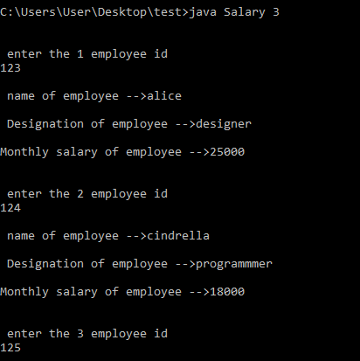
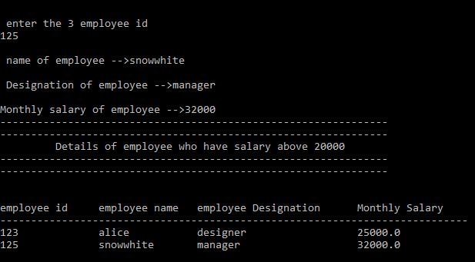

Experiment 5

Objective:: Object Oriented Programming Concepts: Problem on the use of Method Overloading

5. Write a JAVA program to represent Method Overloading.
class adder
{
void add(int a,int b)
{
System.out.println("Add method with 2 parameters");
System.out.println("Sum="+(a+b));
}
void add(int a,int b,int c)
{
System.out.println("Add method with 3 parameters");
System.out.println("Sum="+(a+b+c));
}
void add(float a,float b,float c)
{
System.out.println("Add method with 3 float parameters");
System.out.println("Sum="+(a+b+c));
}
void add(int a,float b)
{
System.out.println("Add method with 2 parameters with first int and then float parameter");
System.out.println("Sum="+(a+b));
}
void add(float a,int b)
{
System.out.println("Add method with 2 parameters with first float and then int parameter");
System.out.println("Sum="+(a+b));
}
void add(double a)
{
System.out.println("Type prommotion");
System.out.println("Sum="+(a+a));
}
}
class meovdemo
{
public static void main(String args[])
{
adder obj=new adder();
obj.add(20,20);
obj.add(20,20,20);
obj.add(30.0f,20.0f,40.f);
obj.add(50,25.0f);
obj.add(50.0f,30);
obj.add(75.0f);
}
}

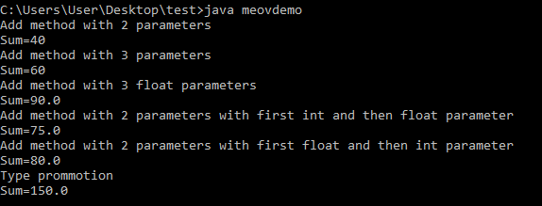

Experiment 6
Objective:: Object Oriented Programming Concepts: Problem on the use of Polymorphism
6. Write a JAVA program to demonstrate the concept of run time polymorphism.
class Animal {
public void displayInfo() {
System.out.println("I am an animal.");
}
}

class Dog extends Animal {
@Override
public void displayInfo() {
System.out.println("I am a dog.");
}
}

class Main {
public static void main(String[] args) {
Dog d1 = new Dog();
d1.displayInfo();
}
}

Output:
I am a dog.

